GOLDSHADOW NETWORK (SECURITY) DESIGN PROJECT

GoldShadow have recently opened a new office in Northeast England, to serve customers and clients more locally. This office will also serve as the new center for HR operations. Examine the proposed floor plan and network layout (attached to the project brief) and identify any potential risks. Additionally, you should suggest changes to mitigate those risks.
The new office space consists of two floors that have been rented from a 5-story building. Due to various issues, the company has not been able to rent two consecutive floors but instead have rented the ground floor and third floor. The ground floor consists of the main HR open office (15PCs), offices for the Legal, Accountancy and HR directors (1 PC each), a meeting room (1PC for a projector for Teams meetings), reception (1 PC) and server rooms 1 and 2. The third floor consists of open plan offices for the rest of the accounting team and Legal team (5PCs each), the technicians office (5 PCs), The CEO’s office (1PC), a recreation area (including open access Wi-Fi) and bathroom facilities, as well as server rooms 3 and 4. There is also a room with filing cabinets to store physical documentation of client contracts etc.

Server room 1 contains the file servers and systems needed to run the accounting department. Occasional access may be required from a third party to maintain specialist accounting software, as well as to maintain the physical servers themselves.

Server room 2 contains backup servers, that will be used to backup electronic records from other sites for the business. This also contains the networking equipment to join the ground floor to the third.

Server room 3 contains file servers, containing the electronic records the site needs for the other departments. This also contains the networking equipment to join the third floor to the ground floor.

Server room 4 is acting as a networking hub, with switches connecting the third-floor rooms to the same network segments.

Currently the first floor is planned to be connected through Ethernet over Power adapters, however the mechanism for connecting the first and third floors has not been decided upon, and in the short term the two floors will be connected through high speed Wi-Fi. The building does not have dedicated ethernet cabling, and only the third floor has immediate plans for cabling to be installed. However, power is separated between floors to allow for accurate billing.

Part 2 (Tasks 2-5)
Analyze their network, make recommendations, and upgrade it to ensure security. This will come in several parts as laid out below.

TASK DELIVERABLES
Task 1
Produce a report detailing the risks the organization faces, prioritized and giving some mitigation ideas for these risks. Your report should be structured in the following manner:
• Introduction
• Risks
• Proposed mitigations
• Conclusions

Task 2
Have a look at the network diagram for your site. Build the basic topology and get it working in the Packet Tracer simulator. This should include:
• Basic router and switch setup and configuration
• Any DHCP services that needed.
• Set up any VLANs and routing protocols as necessary to give you full connectivity across the network before security features are added.

Task 3
Management is aware that the generic subnetting schemes are not suitable. You will need to effectively modify the subnets using a more secure and streamlined approach and submit them as a second simulator file, ensuring that all computers are still accessible.
You should also add any other subnets you think are reasonable and write a brief (max 500 words) report on the subnets you have set up and why.

Task 4
Apply the required internal security features to that network, and then submit it as a third simulator file. This should include:
• Basic Device Security
• The setup and configuration of firewalls, which could be packet filters or stateful zone-based ones as appropriate, which can be router or security appliance based – you will need to add these to the topology where you feel appropriate as this has not been done yet.
• The use of NAT and PAT where needed.
• The securing of routing protocol advertisements with suitable passwords, to prevent unauthorized disclosure of routing information.
• Site to Site VPNs between the buildings to prevent MITM attacks.

Task 5
Provide a commentary describing the security features that have been added in the earlier parts, and why they are there (Max 500 words). This should include:
• Details of the implementation of all the security features.
• Reasoning behind the use of firewall types/and NAT/PAT deployment.
• Reasoning behind the choice of VPN parameters and use of GRE tunnels and elaborate on how you check that the data stream is indeed being encrypted successfully.

PROPOSED DOCUMENTATION %

Task 1 – 30%
Introduction 05%
Risks 10%
Proposed Mitigations 10%
Conclusions 05%
References
Task 2 – 15%
DHCP Setup 05%
VLAN and Routing 10%
This should include a VLAN setup for the Amenities section
Task 3 – 15%
Admin 05%
Servers 05%
Amenities 05%

Task 4 – 20%
Basic Device Security 05%
Firewall Implementation 05%
NAT/PAT Implementation 05%
Routing Protocol Security Implementation 05%
Task 5 – 20%
Security Implementation 05%
Reasoning for Firewalls and NAT/PAT deployment 05%
Reasoning for VPN Parameters and GRE tunnels, with proof of operation 10%
Submission Requirements
You should submit a single zip file containing 3 packet tracer files for parts 2, 3 and 4. You should also submit a single word document containing the written segments for Parts 1, 3 and 5. This word document should be in .doc, .docx or open document format.

PROPOSED FLOOR PLAN

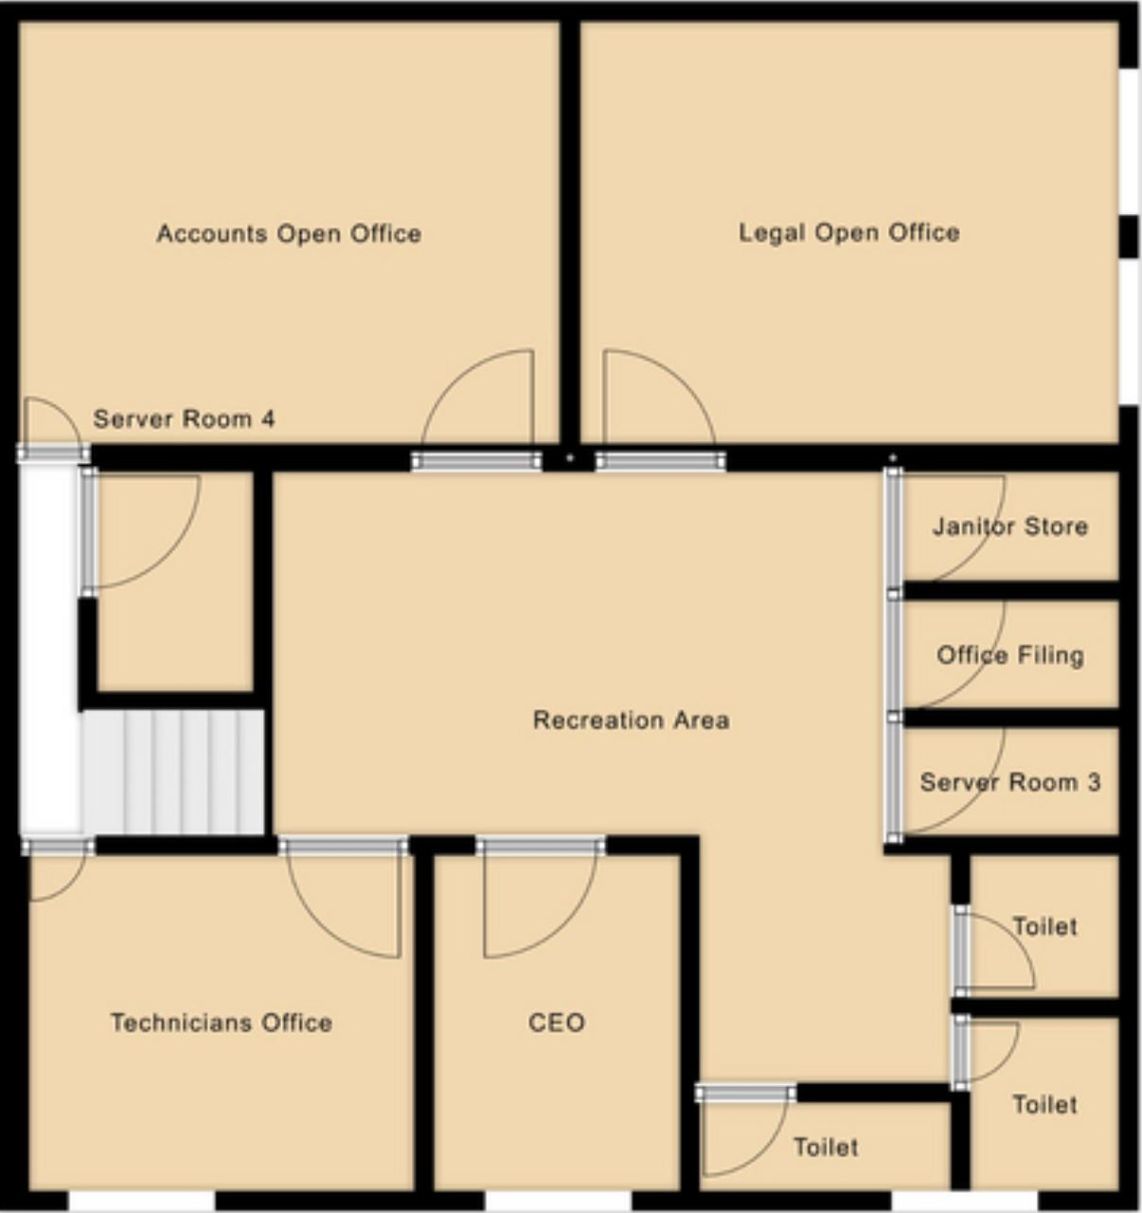

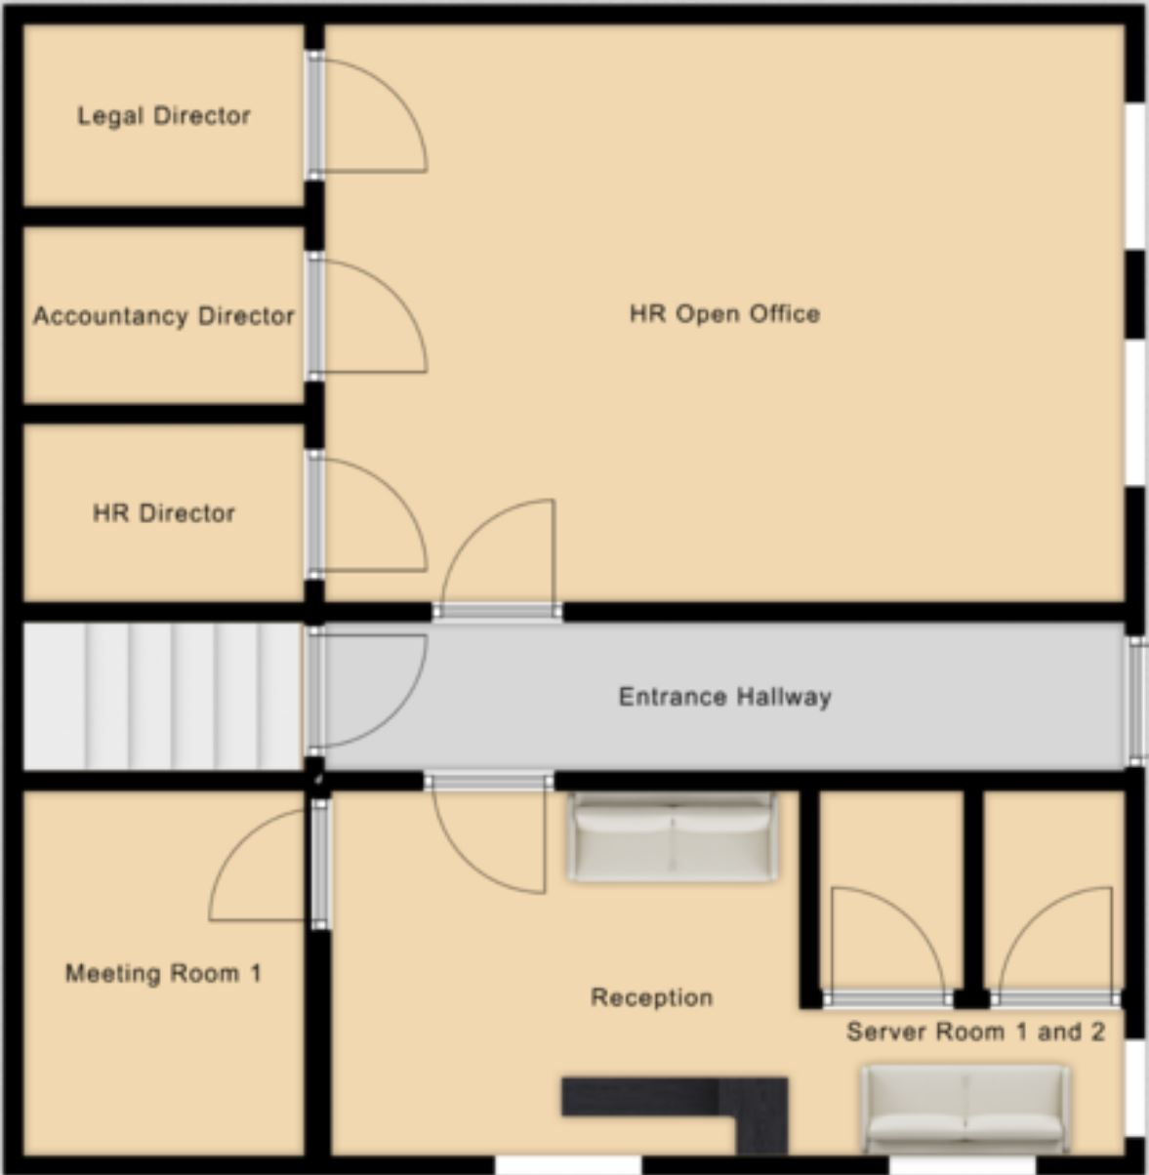

PROPOSED NETWORK LAYOUT
